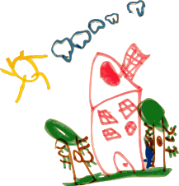
Curriculum

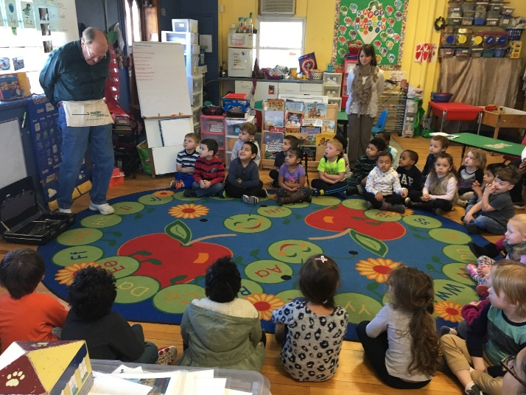
Little Harvard has adopted and implemented the Creative Curriculum. This curriculum takes a play-based approach, in which children learn through engaging in play. Children learn best when they can experience hands-on, real life experiences that they can relate to and take back home to expand on within their own lives. The Creative Curriculum focuses on topics that are relevant to the children and allows these topics to be investigated for as long as the children are interested in the study. The studies include: The Clothing study, the Building study, the Trees study, the Reduce, Reuse, Recycle study, the Beginning of the Year study, the Balls study, the Sand study, the Signs study, the Simple Machines, the Tubes and Tunnels study, and the Insects study. The creative curriculum has shifted from weekly themes into studies, which can range from 4 to 8 weeks depending on each study. The curriculum is student driven and can vary in length based on the children’s interest in the topic. Each study will have several investigations to explore. With the Creative Curriculum, the children will no longer be rotating from center to center, rather they will be participating in choice time. Choice time is a block of time that includes multiple interest areas in which they are free to play in and choose from, such as: art, cooking, discovery, dramatic play, technology, blocks, manipulatives and games, library, and the sand and water tables. Although the children are playing in each interest area, the areas are setup intentionally with materials for them to meet preschool goals and essentially use their imaginations and creativity to drive the curriculum. They will still be learning math, phonics, reading and writing, either within these play areas or during small group instruction, or large group instruction. The small and large group instruction times are designed intentionally to meet preschool standards and goals. Each day the children will also have a question of the day to expand their thinking on the study. The teacher’s role is now to facilitate the activities to encourage the children’s thought process. With this curriculum, the children will still be assessed three times a year based on the pre-k developmental standards aligned to the common core.
